Application of One Dimensional Geophysical Investigation on Proposed Dam Project, Iyah Gbede, Kogi State, Nigeria

OlabodeO.O. ¹,OyanamehO.E. ²,Dorcas Idowu³,Korode, A. I⁴, Osisanya W.O ⁵
¹Department of Geology, University of Ibadan, Ibadan, Nigeria
²Anchor University, Lagos, Nigeria.
³Department of Mines, Colorando School of Mines, Colorando
⁴Department of Petroleum Engineering and Geoscience, Petroleum Training Institute,
Effurun, Nigeria
⁵Department of Physics, University of Benin, Benin City, Nigeria.

Abstract
Foundation designs planning is very critical in engineering works, therefore geophysical investigation was carried out for foundation design of a proposed Dam at IyahGbede, Ijumu Local Government Area of Kogi State with a view to deduce and enhance the knowledge of the near subsurface integrity of the area for engineering structures.Electrical Resistivity method was adopted to conduct the survey for detail and distinct result. The aim of the exercise was to determine the soil properties of the subsoil layers that constitute the foundation soils and their competence as foundation soils for a dam site establishment. Traverse lines were established along E-W direction and six (6) Vertical Electrical Sounding points (VES) which is one dimensional in prospect, werelaid which to reveal the subsurface property of the area.The VES curves types are AA,AH, HA and KH,which depicts that the investigated site is competent for the proposed dam project.
Keywords: Electrical Resistivity Method, Dam Project, Foundation Design, Geophysical Investigation
---------------------------------------------------------------------------------------------------------------------------------------
Date of Submission: 05-01-2021 Date of Acceptance: 20-01-2021
---------------------------------------------------------------------------------------------------------------------------------------

Introduction
IyahGbede of Kogi state is dominated with inhabitants who specialize in agriculture for both subsistence and commercial purpose. Nearness of dependable water supply is one of the key factors necessary for establishment of agricultural farmland for irrigation purpose. IyahGbede area of Kogi state is made of up three stream channels namely Omodo (I&II) and Apala (Fig. 1.0) which can be helpful for water supply to the farmland in the area. Hence, this necessitates the establishment of dam site around the water channels in the area to facilitate easy procurement of water supply from the stream to the farmland for watering the farmland. In order to establish the dam site on a competent foundation, Vertical Electrical Sounding (VES) technique has adopted to investigate the proposed dam site for a strong foundation design for the dam project. The aim of this research work was to determine the soil properties of the subsoil layers that constitute the foundation soils and their competence as foundation soils for a dam site establishment.
A dam is a structure constructed across a river or flowing water body to increase the water level or impede the water from flowing thereby creating a reservoir. An established dam can be used to generate hydroelectricity, flood control, irrigation, recreational activities, fish farming, tourism, regularisation of water flow, navigation etc. Water plays a very important role in life as well as global economy. The livelihood and sustainability of humanity depend largely on availability of water supply (Tanchev, 2014, Pedro L.C and Cesar A.M 2017).
Detailed investigation of basement complex for brittle structure such as faults, fracture, weather basement or weak zones that may be inimical to the competency of damfoundation through water seapage have been successfully conducted using geophysical mapping of proposed dam over time. Electrical resistivity method has proven to be very potent and effective in geophysical investigation of foundation studies as well as proposed dam site project. Dam site dilapidation or collapse often results from severe water seepage as well as subsidence and subfussion (Panthulu et al, 2001, Oglivy et al., 2002). Foundation studies of propose dam site using geophysical approach is gaining ground as a result of availability of sophisticated equipment and data processing.
Globally, electrical resistivity method has been employed for dam pre-construction investigation, dam performance assessments and dam failure investigation. (Di and Wang, 2010, Panthulu et al., 2001, Sjodahet, 2008, Sjodahl et al, 2009; Tabwassah and Obiefuna 2012). The important of electrical resistivity investigation is to differentiate the subsurface lithological resistivity distribution thereby enabling the determination of soil properties of the subsoil layers within the study location. Electrical resistivity method has proven very reliable over years in hydrogeological, geotechnical and mining investigation. Presently, it has been used for dam safety monitoring and environmental survey. Resistivity profiling and/or sounding have been generally adopted in recent years as well as 2-D and 3-D geophysical investigation in dam site project to verify their safety and integrity. (Nasrat A. et al., 2020). However, 2-D/3-D resistivity imaging gives a better vertical and lateral prospect of the subsurface lithological view than geo-electric section generated from 1-D model because of its ability to produce a continuous record of subsurface formation at greater depth (Osisanya et al., 2017)

1.1 SITE LOCATION AND DESCRIPTION
The study area is within UTM reading 0829561 and 0894184. The site is under Ijumu Local Government Area. Physiographically, the state is composed of rocky and undulating landscape. The vegetation consists of guinea savanna in the western parts, wooded savannah and grasslands in other parts of the state. The notable trees are Baobab, Akeer-Apple, Shea-Butter and Mahogany. The principal rivers are River Niger and Benue. The two main seasons experienced in the states are the wet and dry seasons. The wet (rain) season starts by April and ends in October; while the dry season commences by November and lasts till March. November - January is also very cold due to Harmattanwind. The project site area has three stream channels; Omodo (I&II) and Apala (Fig. 1.0). It is accessible through an untarred road. However, the site (Dam Axis) is accessible through farm paths undulating with an uneven topography, with thick vegetations surrounding the Dam axis.
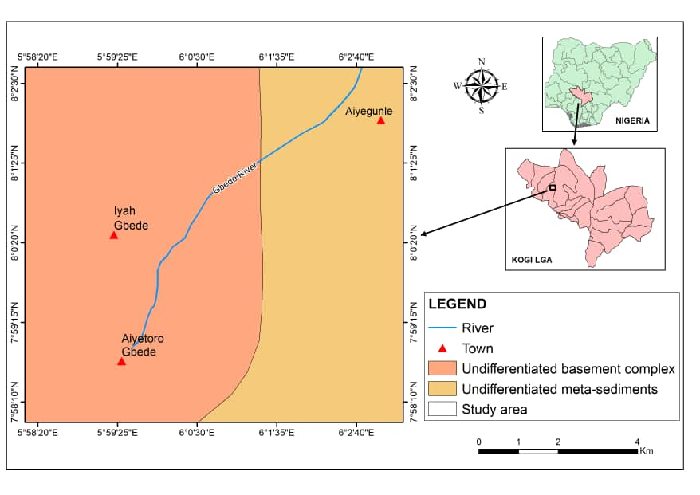
Figure 1: Base Map of the study area.

Geology of The Study Area
The Nigerian Basement Complex forms a part of the North – South trending orogenic belt which Grant (1969), Ajibade and Wright (1989) had shown to extend westward into the Benin Republic, Togo, Ghana; eastward into the Cameroon, and northward into Niger Republic. The crystalline rocks which are exposed today rest on a pre-pan African old basement which is the sialiccrust, Turner (1983).
Field observations and study of the rock indicates that the rocks belong to the Migmatite-Gneiss Complex of the South-Western Nigeria Basement Complex (Fig 2.0). Rocks in the area had regionally been described in the past by previous workers; Jones and Hockey (1964) Grant et al (1972), Odigi et al (1993), Pearce and Gale (1977).The area is underlain predominantly by Biotite-Granite (fig 1.1) as well as Migmatite, amphibolites, coarse grained porphyritic biotite and biotite hornblende granites, Quartz Schists, biotitebiotite hornblende granidorites. Field observations indicate that the Basement Rocks have been subjected to many periods of deformation. The Migmatite Gneiss in the study area had undergone extensive migmatisation which may have nearly obscured and obliterated many of the earlier structures hence preventing comprehensive measurement and further interpretation of the structural evolution of the area. However, the extent or degree of tectonism is expressed in the occurrence and the magnitude of metamorphism and metamorphic structures of the area such as foliation, minor faults, joints and fractures. Consequently, it is suggested that a deformational episode occurred along with the metamorphism of the various rocks of the mapped area and its environs resulting in varied metamorphic derivatives ranging from the amphibolite facies to higher metamorphic facies condition. These migmatites may have been formed from the metamorphism and metasomatism of fractionated igneous bodies during tectonism.The segregation and migration of the melting minerals such as quartz and feldspar during regional metamorphism resulted in the banding of the leucosome and melanosome minerals. The outcrops and their associated foliation generally trend in NNE–SSW directions.

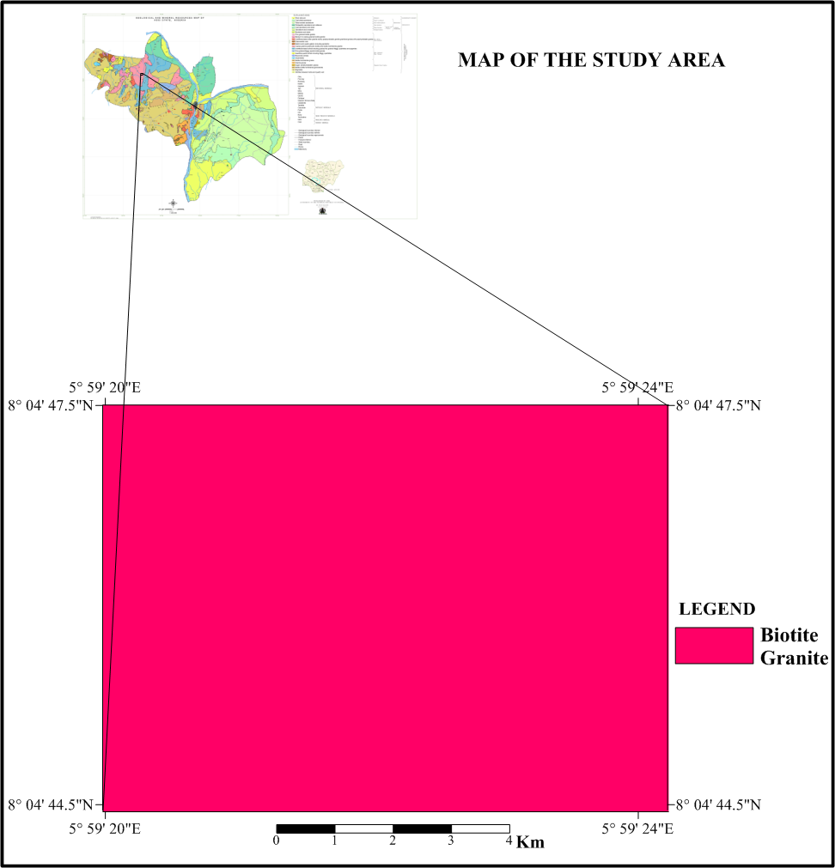

- Materials And Methods

3.1 FIELD WORK
The fieldwork involved reconnaissance and Electrical Resistivity Survey at proposed dam sites. The site work commenced on 22nd January, 2019 and concluded on 24th January, 2019.
It entails:

3.2 Geophysical Investigation
The first stage of the field work is the geophysical investigation that involved the use of electrical resistivity imaging method with the aim of correlating the lithology beneath zones intermediate to successive boring locations with lithology obtained from exploratory boring.
The Electrical Resistivity survey was carried out with a digital PASI 16 GL Resistivity Meter and six (6) Vertical Electrical Sounding points were distributed around the site using the Schlumberger electrode configuration.
Interpretation of the data was achieved by model calculation using the WinRESIST software. Finally, the quantitative interpretations were used to generate sounding curves and 1-D resistivity models of the subsurface.
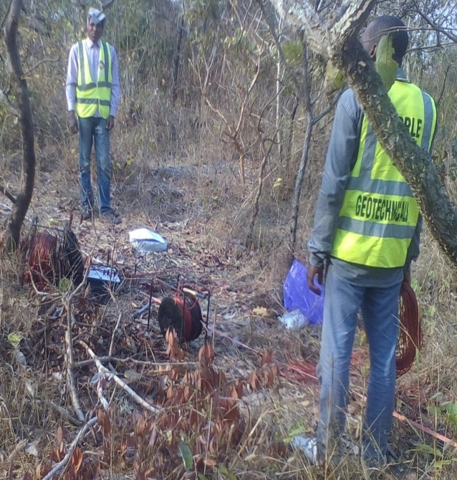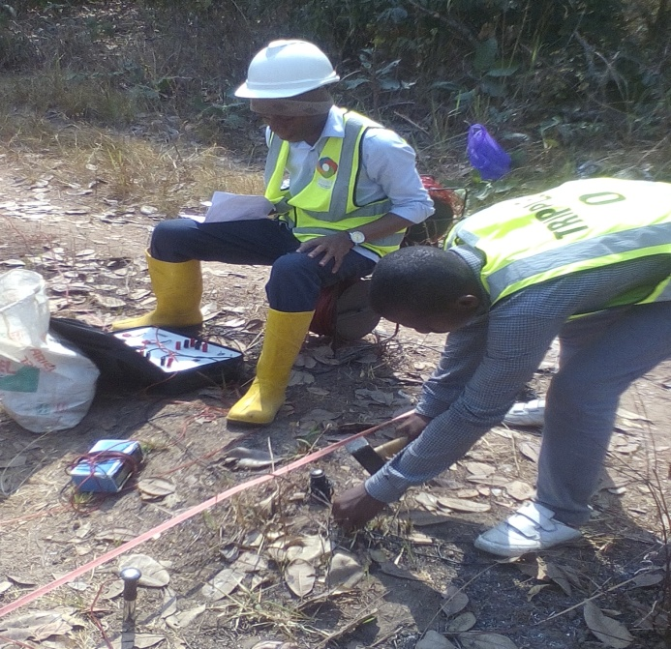
PLATE 1: Pictorial View Geophysical Survey on Site

- Discussion Of Results
A relatively uniform sequence was delineated beneath the sounding stations comprised essentially of five-Six major geo-electric layers to varying depths and the result of the interpretation of the soundings is summarized in the (Tables 1-6). The geo-electric curves and apparent resistivity readings are highlighted and attached in the appendixes. Generally, resistivity values obtained beneath the sounding stations are very high indicating presence of fresh bedrocks and relatively partial fractured rock in VES 1-5. The shallow overburden depth is as a result of the wide extensive low lying rock at the dam site. The overburden thickness is of the variation of about 0-3m across the six (6) sounding points. The average depth of fracture as observed from the geo-electric cross section and lithologic layers across the Vertical Electrical Sounding points is about 7m. For VES 1, The first layer is the topsoil having resistivity values of 4330 Ωm , 337, 2458,251, 6123 and 19930Ωm at second, third, fourth, fifth and sixth layers respectively for VES 1. The slight drop in resistivity at the fourth to a depth of 13.8m indicates a slight fractured zone. The fresh bedrock extends from 29.3m to beneath the fifth layer.
VES 2 comprises of about five layers. The first layer is the lateritic soil having a resistivity value of 16 Ωm followed by weathered rock with resistivity of 2980 Ωm .The third layer is a fractured rock with resistivity value of 1524 Ωm which terminates at a depth of about 4m before entering a fresh bedrock.
VES 3 constitute five geoelectric layers with the top most layer having a resistivity value of 72382 Ωm. The second dropped in resistivity to the tune of 75 Ωm indicating a lateritic sediment. The third is a weathered rock with resistivity value of 305 Ωm which is underlained by a fractured rock.
VES 4 is made up of five geolectric layers. The first layer is the topsoil with resistivity value of about 242 Ωm. The second layer is weathered sediment with the resistivity value of 828 Ωm. the third, fourth and fifth layers are bedrocks resistivity values of 6198, 100,000 and 34523 Ωm.
VES 5 is made up of six geo-electric layers. The topmost layer, weathered rock, fractured section and fresh bedrock while VES 6 entails topmost layer, lateritic material, weathered layer and basement.
The very low resistivity values obtained from the horizons are interpreted as characterizing the presence of weathered /partially fractured bedrocks.
The overburden of all sounding varies from 0-3m across the vertical electrical sounded points.

Table 4.1: Summary of Results
(08˚ 33̍ 006, 005.44 814) VES 1
Layers | Resistivity (Ωm) | Thickness (m) | Depth  to layer base (m) | Lithology
1 | 4300 | 0.6 | 0.6 | TOPMOST SOIL
2 | 337 | 1 | 1.6 | WEATHERED ROCK
3 | 2458 | 2.6 | 4.2 | BEDROCK
4 | 251 | 9.7 | 13.8 | FRACTURED ROCK
5 | 6123 | 15.5 | 29.3 | BEDROCK
6 | 19930 |  |  | BEDROCK

Table 4.2: Lithology of Layers for VES 2
(08˚ 33̍ 015, 005 44823) VES 2
Layers | Resistivity (Ωm) | Thickness (m) | Depth  to layer  base (m) | Lithology
1 | 16 | 0.4 | 0.4 | LATERIRIC SOIL
2 | 2980 | 2 | 2.3 | WEATHERED ROCK
3 | 1526 | 1.3 | 3.6 | FRACTURED ROCK
4 | 6214 | 5.2 | 8.8 | BEDROCK
5 | 100,000 |  |  | BEDROCK

Table 4.3: Lithology of Layers for VES 3
(08˚32̍898, 005 43584) VES 3
Layers | Resistivity (Ωm) | Thickness (m) | Depth  to layer  base (m) | Lithology
1 | 72382 | 0.2 | 0.2 | TOPMOST SOIL
2 | 75 | 1 | 1.2 | LATERITIC SOIL
3 | 305 | 1.7 | 2.9 | WEATHERED ROCK
4 | 135 | 3.6 | 6.4 | FRACTURED ROCK
5 | 1484 | 4.5 | 11.0 | BEDROCK
6 | 8905 |  |  | HARD BEDROCK

Table 4.4: Lithology of Layers for VES 4
(08˚ 32̍ 458, 005 43897) VES 4
Layers | Resistivity (Ωm) | Thickness (m) | Depth  to layer base (m) | Lithology
1 | 242 | 1.4 | 1.4 | TOPMOST SOIL
2 | 828 | 0.5 | 2.0 | WEATHERED ROCK
3 | 6198 | 1.0 | 2.9 | BEDROCK
4 | 100,000 | 31.3 | 34.3 | HARD BEDROCK
5 | 34523 |  |  | BEDROCK

Table 4.5: Lithology of layers for VES 5
(08̍ 33̍ 017, 005 45756) VES 5
Layers | Resistivity (Ωm) | Thickness (m) | Depth  to layer  base (m) | Lithology
1 | 45 | 0.4 | 0.4 | LATERIRIC SOIL
2 | 1978 | 1.1 | 1.5 | WEATHERED ROCK
3 | 71 | 3.6 | 5.1 | FRACTURED ROCK
4 | 2397 | 4.8 | 9.9 | BEDROCK
5 | 10249 | 8.7 | 18.6 | BEDROCK
6 | 100000 |  |  | HARD BEDROCK

Table 4.6: Lithology of Layers for VES 6
(08˚ 33̍ 108, 005. 45567)VES 6
Layers | Resistivity (Ωm) | Thickness (m) | Depth  to layer  base (m) | Lithology
1 | 48 | 0.7 | 0.7 | TOPMOST SOIL
2 | 23 | 0.9 | 1.6 | LATERITIC SOIL
3 | 149 | 0.9 | 2.5 | WEATHERED ROCK
4 | 2299 | 3.1 | 5.6 | BEDROCK
5 | 100000 | 212. | 217.6 | HARD BEDROCK
6 | 9303 |  |  | BEDROCK

- Conclusion
Ground geophysical surveys of resistivity are routinely used for engineering and geotechnical works. Therefore, ER used in the investigation of proposed dam was effective and the underlain materials was discovered to be competent, VES curve types deduced from the investigated site reveals that the site is good for the location of the proposed dam.
After a critical analysis with the use of Electrical Resistivity method, the resistivity values obtained from the field are high and the overburden is shallow which is good for engineering and geotechnical works. Therefore the area is good for the citation of proposed dam.

APPENDICES
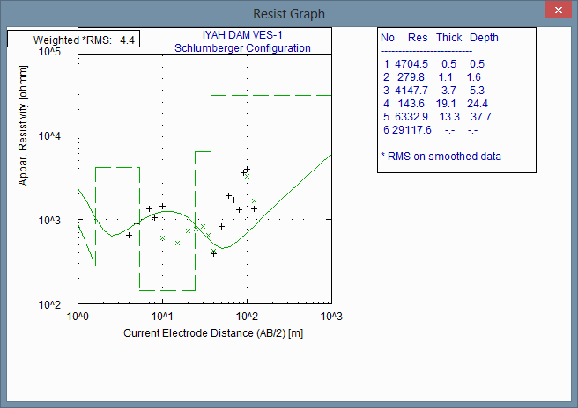
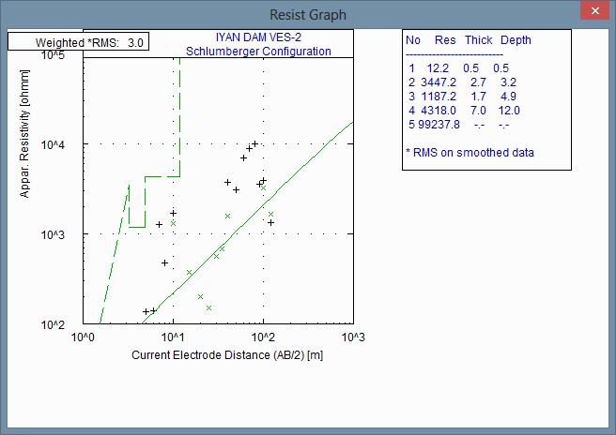
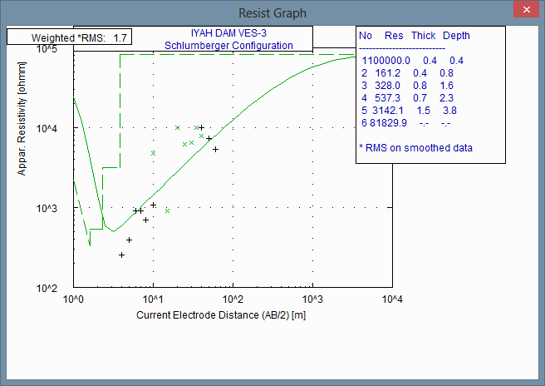
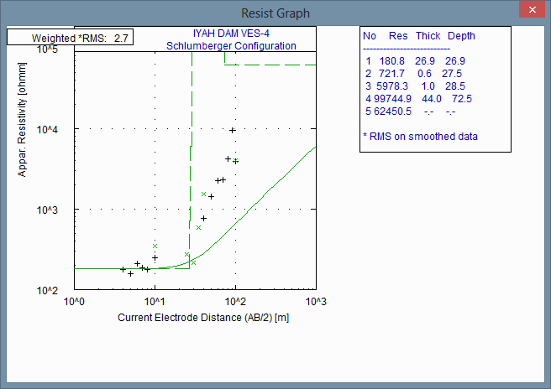

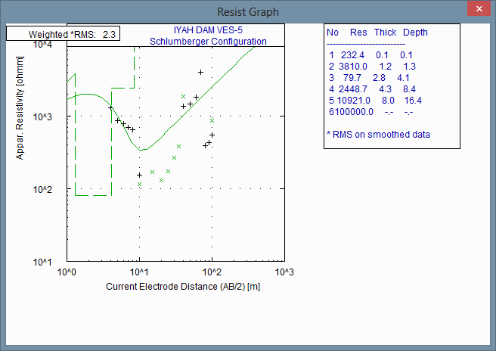
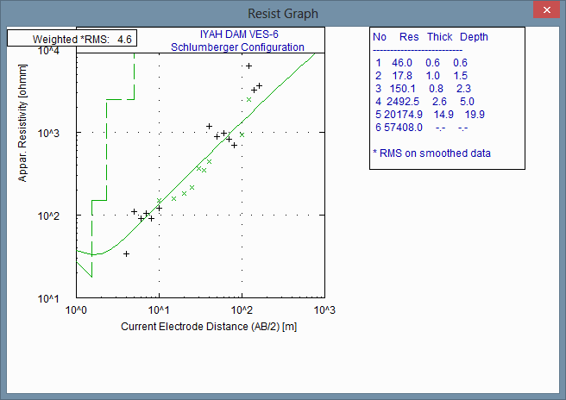

References
- Ajibade, A. C., & Wright, J. B. (1989). The Togo-Benin-Nigeria shield: evidence of crustal aggregation in the Pan-African belt. Tectonophysics, 165(1), 125–129.
- Di, Q. and Wang, M. (2010) Determining areas of leakage in the Da Ye Dam using multi-electrode resistivity. Bulletin of Engineering Geology andEnvironment. 69,105-109
- Grant, F.S. and West, G.F., 1965, Interpretation Theory in Applied Geophysics, McGraw Hill, New York
- Grant NK, Hickman MH, Burkholder FR, Powell JL (1972) Kibaran metamorphic belt in Pan-African domain of West Africa. Nature 238:90–91 Jones, H.A. and Hockey, R.D. (1964): The Geologyof the part of Southwestern Nigeria. GeologicalSurvey Nigeria Bulletin, No 31, Pp. 101.
- Grant, R.W., Housley, R.M., and Geller, S. (1972) Hyperfine interactions of Fe2+ in ilmenite. Physical Review B, 5, 1700–1706.
- NasratAdamo, Nadhir Al-Ansari, VaroujanSissakian, Jan Laueand Sven Knutsson (2020); Geophysical Methods and their Applications in Dam Safety Monitoring. Journal of Earth Sciences and Geotechnical Engineering, Vol.11, No.1, 2020, 291-345 ISSN: 1792-9040 (print version), 1792-9660 (online) https://doi.org/10.47260/jesge/1118 Scientific Press International Limited
- Odigi, M. I. and Ezepue, M. C., 1993. Journal of mining and geology, vol. 29 (1), pp 41-50
- Ogilvy, R.D., Meldrum, P.I., Chambers, J.E., Williams, G. (2002). The use of 3D electrical resistivity tomography to characterize waste and leachate distributions within a closed landfill, Thriplow, UK. J. Environmental and Engineering Geophysics. 7, 11–18.
- Osisanya O.W, Ibitoye A. T., Eze S, Ezomo F.O and Okeh O (2017): Delineation of Laterite Deposits using Two-Dimensional Geo-Electric Imaging in Agbonmwoba Village Area of Obaretin Town, Edo State, Nigeria. Journal of Emerging Trends in Engineering and Applied Sciences (JETEAS) 8(6):233-243 © Scholarlink Research Institute Journals, 2017 (ISSN: 2141-7016) jeteas.scholarlinkresearch.com
- Panthulu T.V., Krishnaiah, C. and Shirke, J.M. (2001). Detection of seepage paths in earth dams using self-potential and electrical resistivity methods. Engineering Geology, 59, 281-195.
- Pearson G.N., Kelley S.P., Pokhilenko N.P. & Boyd F.R. (1997) Laser 40Ar/39Ar dating of phlogopites from southern African and Siberian kimberlites and their xenoliths: constraints on eruption ages, melt degassing and mantle volatile compositions. Russian Geol. Geophys., 38, 106–118 (English edition).
- Pedro L.C. and Cesar A. M (2017); Geophysical Investigation of earth dam using the electrical tomography resistivity technique. Geosciences Geociências. https://www.researchgate.net/publication/312569653
- Sjödahl, P., Dahlin T., Johansson, S. and Loke, M. H. (2008). Resistivity monitoring for leakage and internal erosion detection at Hällby embankment dam. Journal of Applied Geophysics, 65, 155-164.
- Sjödahl, P., Dahlin T. and Johansson, S. (2009). Embankment dam seepage evaluation from resistivity monitoring data. Near Surface Geophysics, 463-474.
- TANCHEV, L. Dams and appurtenant hydraulic structures. (2° ed.). London: Taylor & Francis Group, 1073. p., 2014.
- Tabwassah, C. A. and Obiefuna G. I. (2012). Geophysical and Geotechnical Investigation of failed Cham Dam Project, NorthEast Nigeria. ResearchJournal of Recent Sciences, 1(2), 1-18.
- Turner DC (1983). Upper Proterozoic schist belts in the Nigerian sector of the Pan-African Province of West Africa. Precamb. Res., 21:55-79.
OlabodeO.O, et. al. “Application of One Dimensional Geophysical Investigation on Proposed Dam Project, Iyah Gbede, Kogi State, Nigeria.” IOSR Journal of Applied Geology and Geophysics (IOSR-JAGG), 9(1), (2021): pp 12-20.

